|  |  |
| --- | --- |
| No. of Pages | **7** |
| No. of Questions | 8 |

**Department of Computer Science and Engineering**

**FINAL EXAMINATION SPRING 2015**

**CSE421/EEE465: Computer Networks**

**Total Marks: 90 Time Allowed: 3 Hours**

* Answer **Any** **Six (6)** questions out of **Eight (8)** questions.
* Figure in bracket [] next to each question indicates marks for that question.

## Question No. 1

1. What parameters need to be the same for routers running ospf to be neighbors? [3 marks]
2. List the steps that a router running ospf would follow to find the best paths to different networks, starting from discovering neighbors. [5 marks]
3. In DR and BDR selection in a NBMA network, what do you have to do so that a particular router will not be selected as DR neither as BDR? [3 marks]

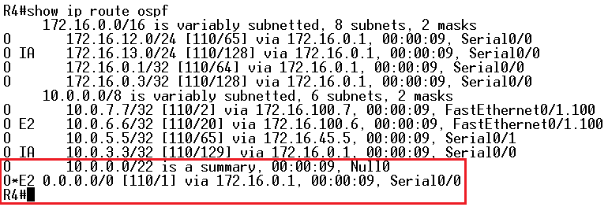

**Figure no. 1**

1. A router running OSPF shown in figure no. 1 has an O*E2 route. How did the router R4 learn about this route? How will this route help R4 to route packets? [4 marks]

## Question No. 2

1. A router has a RIP route to 192.168.4.0 in its routing table, with metric 5 hops. It receives information that the route is down, and it starts its hold-down timer. [4 marks]
   1. What will it do if it now receives a regular update giving a route to 192.168.4.0 with 6 hops?
   2. What will it do when it receives no updates within 180 seconds, i.e when the timer runs out?

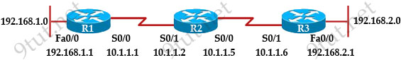

**Figure no. 2**

1. The network shown in the exhibit is running the RIPv2 routing protocol. The network has converged, and the routers in this network are functioning properly. The FastEthernet0/0 interface on R1 goes down. In which two ways will router R2 router in this network respond to router R3 when it has received an update from R1 about the change? [4 marks]
2. A router has learned three possible routes that could be used to reach a destination network.  
   One route is from EIGRP and has a composite metric of 20514560. Another route is from OSPF with a metric of 782. The last is from RIPv2 and has a metric of 4.Which route or routes will the router install in the routing table and why? [3.5 marks]
3. Router 1 is running RIPv2, and the “auto summary” has been issued in Router 1 shown in figure no. 3. Which route/s will Router 1 advertise through its serial port s0/0? Show calculations. [3.5 marks]

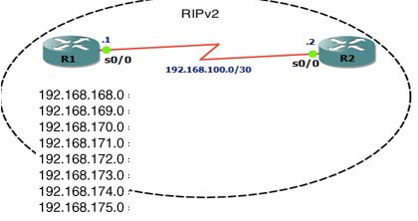

**Figure no. 3**

**Question No. 3**

1. A router running EIGRP has 3 serial connections and is running IP and IPX protocol simultaneously, how many tables will this router maintain? [4 marks]
2. What is the advantage of EIGRP storing feasible successor routes as well as successor routes? [3 marks]

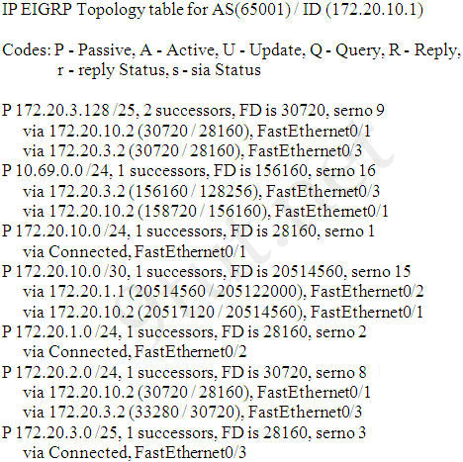

**Figure No. 4**

1. Refer to the exhibit shown in figure no. 4, which EIGRP routes will be installed for the 172.20.3.128 /25 and 172.20.2.0/24 networks in the routing table from the topology table shown and why? [4.5 marks]

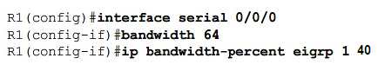

**Figure No. 5**

1. Refer to the commands shown above, R1 router will use how much bandwidth to send EIGRP updates through its serial 0/0/0 link? (Show calculations) [3.5 marks]

## Question No. 4

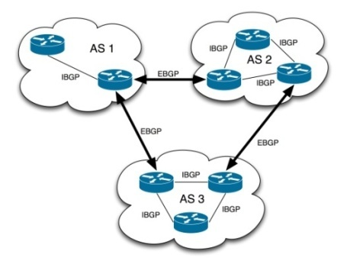

**Figure No. 6**

1. The Autonomous Systems shown in the above figure no.6 are of what type, explain your answer? [3 marks]

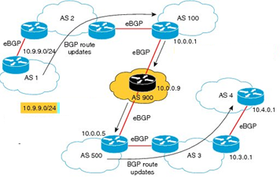

**Figure No. 7**

1. In figure no. 7, a BGP update for network prefix 10.9.9.0/24 is sent from AS1 and that update is forwarded by each autonomous system as shown by the arrow. What attributes are included in the update? Show what AS_PATH and NEXT_HOP IP attributes will contain when the update reaches AS4 BGP router? [5 marks]
2. Refer to the diagram below in figure no.8 should AS2 or AS6 allow AS4 to route packets to AS3 when the link from AS4 to AS3 is down? [3 marks]

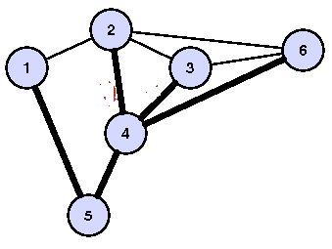

**Figure No. 8**

1. Using the above topology shown in figure no. 8, explain how BGP prevent loops being formed? [4 marks]

###### Question No. 6

1. Assume that we request an object a.html from [www.bracu.](http://www.bracu.)ac.bd. In this case, is there any advantage of using “persistent” connection to [[www.bracu.](http://www.bracu.)ac.bd.](http://www.utsa.edu) over “nonpersistent” connection? Why or why not? [4 marks]
2. During HTTP process, what is conditional GET request that the proxy servers use? [4 marks]
3. In “Traceroute” application, the originator sends the first packet with TTL=1, when this packet reaches the first hop, what kind of packet does the router sent in reply? [2 marks]
4. TTL reduces congestion, how? [2 marks]
5. Why does IPv4 must further fragment a packet? If fragmentation occurs how a receiver knows that it has received the last packet? [3 marks]

## Question No. 5

1. A host sends 3 segments. Segment 2 is lost, that is it never reaches the receiving host. What are the probable actions to be taken by the receiving host? [4 marks]
2. What is the difference between Back Pressure and Choke Packet congestion control? [3 marks]

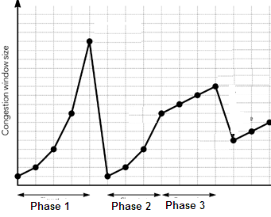

**Figure no. 9**

1. In the above figure no. 9, shows a graph of TCP congestion control. Identify what is phase 1,2 and 3? After phase 1, there is a sharp drop, why? [5 marks]
2. In TCP congestion control, what is the purpose of “ssthresh” variable? [3 marks]

###### Question No. 7

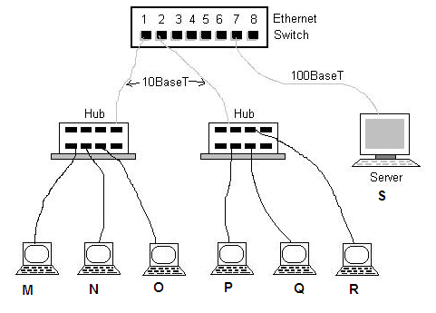

**Figure no. 10**

1. How many collision domains exist for the network topology above shown in figure no. 10? How many collision domains will exist if the hubs are replaced by switches? [3 marks]
2. In figure no. 10 above, what does 10BaseT and 100BaseT stand for? Can we change the two ports of the switch running 10BaseT to 100BaseT, why or why not? [4.5 marks]

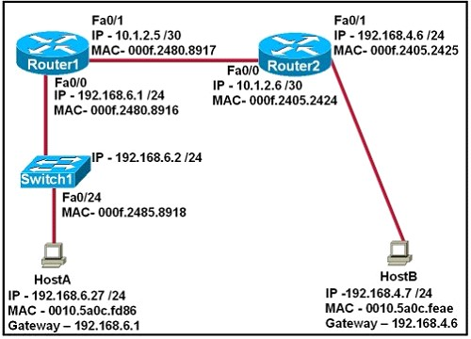

**Figure no. 11**

1. Host A is pinging Host B. For the ping packet the source IP is 192.168.6.27/24 and destination IP is 192.168.4.7/24 and source MAC is 0010.5a0c.fd86. If the ARP cache of Host A is empty, how will Host A find Host B’s MAC to put it in the destination MAC address slot? [3.5 marks]
2. In the CRC method, how does the receiver decide that the data received is corrupted? [4 marks]

###### Question No. 8

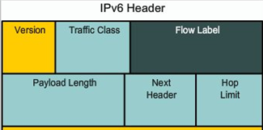

**Figure no. 12**

1. The above figure no. 12 represents the partial header of IPv6 (Source IP and Destination IP not shown). Explain the purpose of Next Header and Hop Limit and did IPv4 have a similar header that is a header for the same purpose? [4 marks]
2. Broadcasts addresses are no longer present in IPv6, so how are we sending packets to all nodes or host in a network? [3 marks]

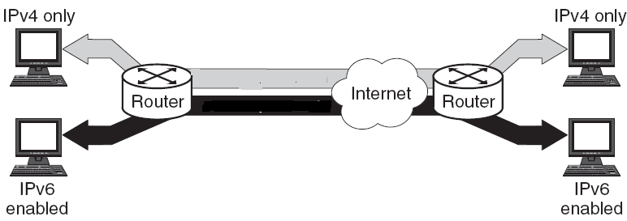

**Figure no. 13**

1. For the above scenario shown in figure no. 13, what type of transition strategy should be taken to make the transmission of packets efficient? [4 marks]

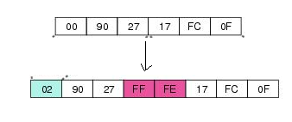

**Figure no. 14**

1. How was the MAC address shown converted to an Interface ID to be inserted in an IPv6 address of a device using EUI-64 shown in the above figure no. 14, explain? [4 marks]

##### THE END